ENEL 420 Advanced Signals

Department of Electrical and Electronic Engineering

University of Canterbury

Assignment 2

Aliasing and Anti-Aliasing Filters

GROUP 19

Pakorn Arunchayanon (78980462)

Sasiru Goonatillake (51643980)

# Introduction

In the modern world, real-world signals such as audio, voice, video, sensor data (temperature, pressure etc.) will be digitized for convenient digital manipulation. The process of converting analogue signals to digital signals and mathematically manipulating them is known as Digital Signal Processing (DSP). One of the first steps in DSP is sampling an analogue signal, where a continuous signal is multiplied by a set of discrete inputs (A Dirac Comb), illustrated in Figure 1. The analogue signal is sampled at a sampling frequency (fs) with the intention of recreating the signal at the end of the DSP.

Figure 1: Continuous-time signal multiplied by a Dirac Comb to sample the signal. [5]

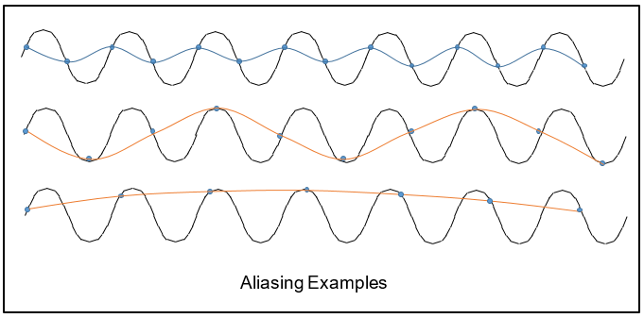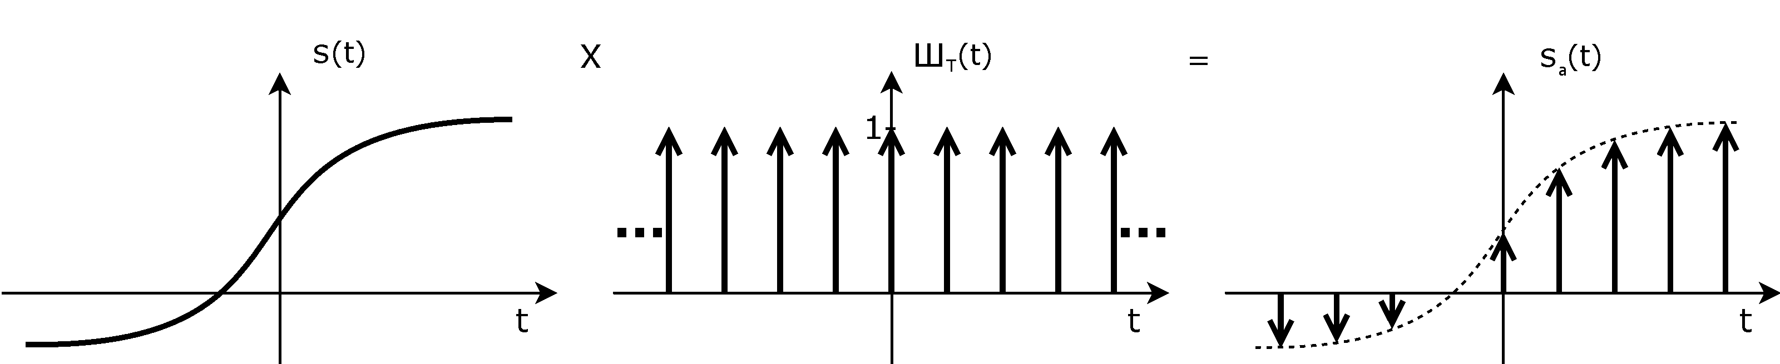The Nyquist Shannon Sampling Theorem states that a continuous-time signal can be sampled and perfectly reconstructed from its samples if the signal is sampled at over twice as fast as its highest/maximum frequency component [1]. No information can be gained or lost by sampling at a faster speed than the Nyquist Rate, although oversampling leads to more resource usage. When the sampling frequency is lower than the Nyquist Rate the signal is under sampled and as a result aliasing occurs (fs < fm).Figure 2￼ presents various instances of aliasing as a result under sampling the same continuous time signal.

Figure 2: Aliasing due to under sampling

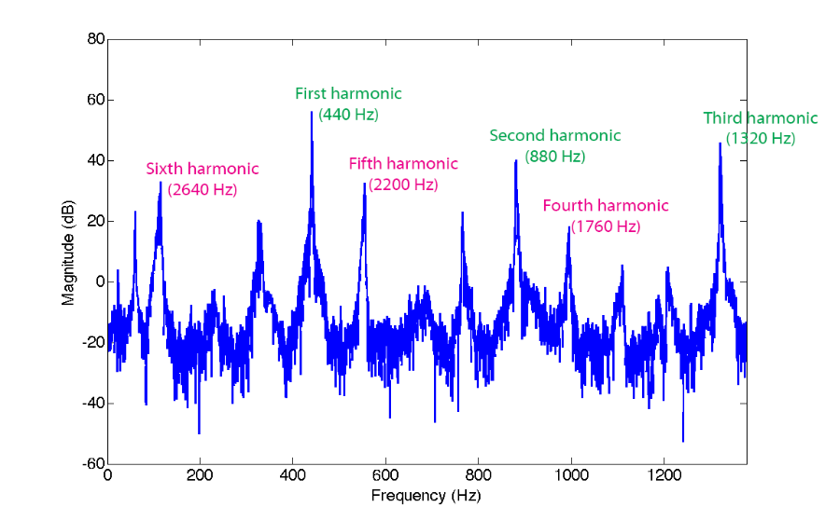When aliasing occurs signals of higher frequency components of a sampled signals becomes indistinguishable from lower frequency components. Figure 3 below, displays the frequency spectrum of a saxophone note that is sampled at 2756 Hz. While the first three harmonics (up to 1378 Hz) can be seen clearly in the graph, as they have a lower frequency than half the sampling frequency (fs/ 2 = 1378 Hz). The last three harmonics can be seen reflected as they have a greater frequency than 1378 Hz. These reflected harmonics introduce a buzzing attributes to the signature tonal sounds of wi [2]￼.

Figure 3: Aliasing present in a saxophone recording [2]

# Theory

The solution to aliasing is described by the Nyquist-Shannon Theorem which states that sampling higher than twice of the Nyquist rate will eliminate the loss of information [3]. Sampling at a higher rate solves the problem of aliasing from under sampling but aliasing can still occur from high frequency noise. Signals often contain noise which are higher than the Nyquist rate and may alias with the wanted signal causing a distortion, shown in Figure 3. This is where an anti-aliasing filter is used to attenuate the high frequency noise.

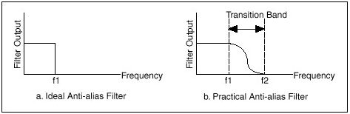Anti-aliasing filters are low-pass filters which blocks frequencies higher the set cut-off frequency and will allow low frequencies to pass through. The main purpose of anti-aliasing filter is to eliminate high frequency noise which is higher than the Nyquist rate. There are a few things to consider before designing an anti-aliasing filter, the amount of attenuation in the passband, the steepness in the transition, the desired roll-off in the stopband and the phase relationship of the different frequencies as they pass through the filter. The bandwidth of the acquisition system is required to set the cut-off frequency and determine the minimum sampling rate, which is twice the bandwidth. Realisable anti-aliasing filters can’t attenuate signals higher than the cut-off frequency as abruptly as that of a perfect theoretical filter, so sample rate should be much higher than twice of the bandwidth. Some systems sample as high as five to ten times of the bandwidth. High sample rates give more accurate samples, but it also requires more memory to store more samples.

Figure 4 Theoretical filter vs realizable filter

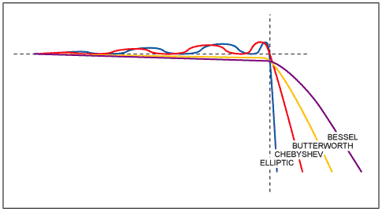Anti-aliasing filters can be separated into two categories, analog filters and digital filters. Analog filters are circuits made of analog components such as capacitors, resistors, op-amps and inductors. Digital filters are usually embedded in a chip that operates on digital signals, such as an MCU and DSP (Digital Signal Processor). Both analog and digital filters have sub-categories, where analog filters are categorised into passive and active filters and digital filters are categorised into Finite Impulse Response (FIR) and Infinite Impulse Response (IIR) filters. Nowadays, digital filters are mostly used for separation of signals and restoration of signals. Analog filters can be used to do the same tasks, but digital filters are able to achieve higher accuracy [4].

Figure 5 Graph of different filter characteristics

There are many types of filters available designed to meet different requirements. Some of the common low-pass filters are Butterworth, Bessel, Chebyshev and Elliptic. Each of the listed filters have different characteristics, different transition widths and ripples. Figure 5 shows have been graphed to visually show the different characteristics of each filter.

# Chosen Application

The assignment requires a demonstration to showcase the teams understanding and the application of both aliasing and anti-aliasing filters. The effects of aliasing can be visually showcased using a frequency spectrum and adjusting the sampling rate of any signal. For the purpose of an easier to grasp demonstration the team chose to use audio samples/signals.

Various audio clips will be used to showcase the effects of aliasing by adjusting the sample rate and or by adding high frequency interference components to the signal. This will allow for a more realistic/practical understanding of the effects of aliasing.

A musical instrument (wind instrument) will be used to obtain samples will be used for the second part of the assignment which discusses various anti-aliasing filters. Musical instruments were chosen because the effectiveness of each anti-aliasing filter will be more pronounced and noticeable in music sample rather than an audio sample of conversation. This is due to more observable harmonics generated from a musical instrument as seen in Figure 3.

Pure tones, generated using a frequency generator, can also be used for understanding and demonstrating the effects aliasing and anti-aliasing filters.

# Plan for the Project

The plan for the project is as follow:

1. Build a platform on python which allows us to extract frequency spectrum data from audio files and apply filters. **16th September**
2. Acquire various audio samples and a sample of a woodwind or brass-wind musical instrument which are harmonic. **17th September**
3. Further research into various types of anti-aliasing filters **21st September**
4. Building the filters in python **24th September**
5. Applying the filters and gathering the results **26th September**
6. Prepare for the demonstration by making the python platform more usable and presentable. **1st October**
7. A screenshot of a social media post

   Description automatically generatedFinish the report? **10th October**

Figure 6 Gantt Chart of the project timeline

# References

|  |  |
| --- | --- |
| [1] | T. Smyth, “Nyquist Sampling Theorem,” Department of Music, University of California, 15 October 2019. [Online]. Available: http://musicweb.ucsd.edu/~trsmyth/digitalAudio171/Nyquist_Sampling_Theorem.html. [Accessed 11 September 2020]. |
| [2] | 3. Creative, “ALLSIGNALPROCESSING.COM,” 25 April 2015. [Online]. Available: https://allsignalprocessing.com/2015/04/25/aliasing-of-signals-identity-theft-in-the-frequency-domain/. [Accessed 11 Spetember 2020]. |
| [3] | E. Por, M. v. Kooten and V. Sarkovic, “Nyquist-Shannon Sampling Theorem,” May 2019. |
| [4] | A. V. Oppenheim, A. S. Willsky and S. H. Nawab, “Signals & Systems,” Prentice-Hall, Inc, 1996. |
| [5] | Taschenrechner, “Wikimedia Commons,” 6 September 2005. [Online]. Available: https://upload.wikimedia.org/wikipedia/commons/6/6a/Dirac-comb_-_Sampling.png. [Accessed 11 Spetempber 2020]. |